Fur and Feather Haven’s Sale Policy
PLEASE read our entire sales policy. If you buy a rabbit from us, that means that you have read this and agree to the terms stated within.
General Policies:
- A rabbit sold as show quality is not guaranteed to win at shows. A rabbit sold as brood quality is not guaranteed to produce kits.
- A rabbit’s personality is NEVER guaranteed.
- NO sales to anyone under the age of 18 without prior parental consent and signature. We love seeing youth involved, but we want to ensure the parents are okay with the child having a rabbit first. If you are under the age of 18, have your parents contact us first. Anyone under 18, must be accompanied by a parent at time of pick-up.
- You are responsible for evaluating the rabbit for any disqualifications and/or any other unwanted traits. We will disclose what we know but things change as rabbits grow.
- We do NOT guarantee sex of a rabbit until at least 12 weeks of age.
- If for any reason, you cannot keep your rabbit within 6 months of the purchase date, you agree to contact us, and we will take the rabbit back if you have no other home for it. No questions asked, but the rabbit must be healthy (we will inspect it). We will not refund your purchase price. If the rabbit is not in Wisconsin, we cannot take them back.
Health Warranty:
We warrant the health of a rabbit for 72 hours after pick-up. If something happens, such as illness or death, contact us ASAP to discuss whether you will be considered for a refund. We do NOT do exchanges. If an illness or death happens within 72 hours of purchase, you will need to provide us a written diagnosis from a certified vet and you are responsible for the cost of the vet. This health policy does not apply to any rabbits that have been transported by shippers, neglected, stressed, or mishandles in any way.
Payment/Pedigrees:
We ONLY accept cash or PayPal for animals being shipped. NO CHECKS. Only show quality rabbits are sold with pedigrees. The price will include pedigree, unless otherwise stated. Pet rabbits are not guaranteed to come with pedigrees. Pedigrees are not to be altered in any way. The are null and void if you do.
Delivery:
We will deliver a rabbit within 25 miles of our rabbitry for an additional fee of $20. Any delivery destination over 25 miles, the additional fee will be $1 per mile.

Thanks for your business. We appreciate your interest in our rabbits.
Amanda Hedlund 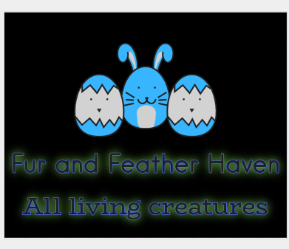
Fur and Feather Haven
Albany, WI
Rockgirl_16@live.com

Rabbit Ear #

Breed:

Price: $

Date Purchased:

Buyer Name:

Buyer Address:

Phone #:

Email:

